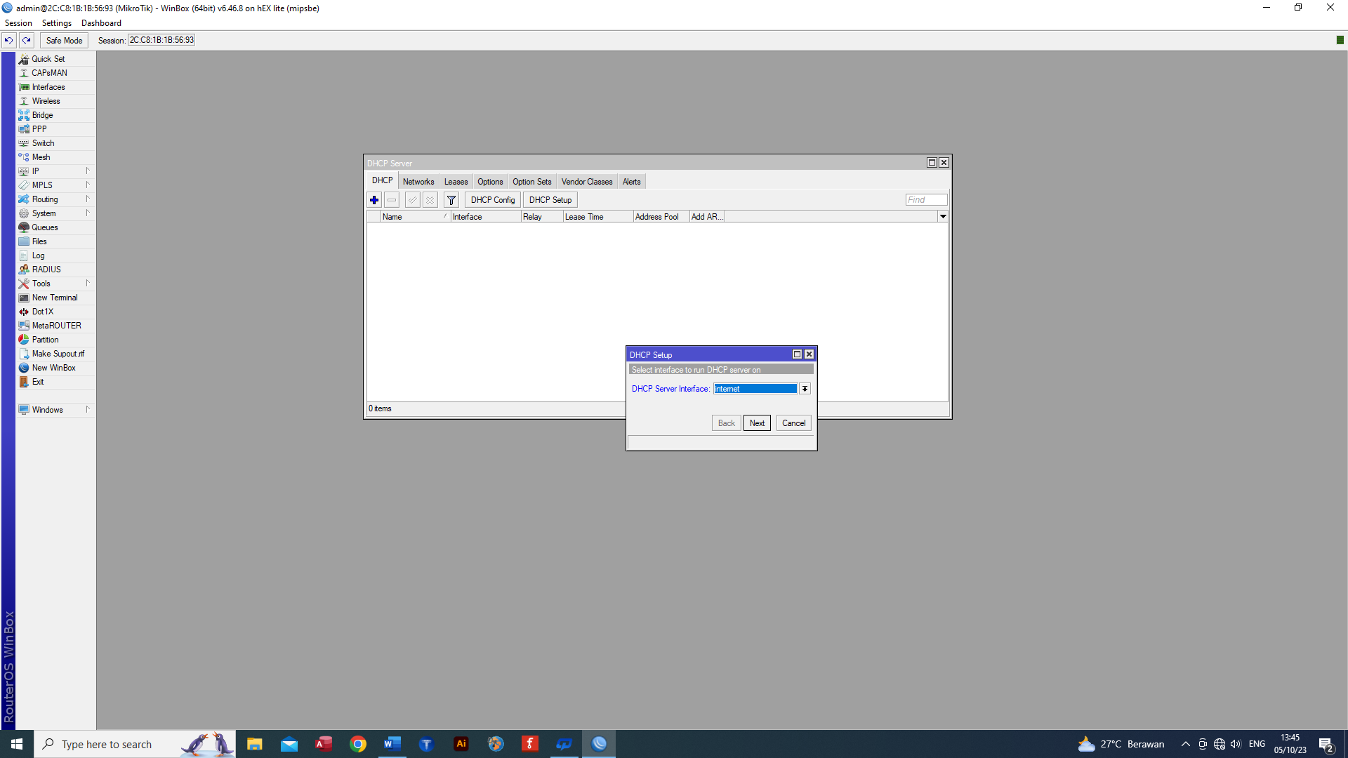

Ip, pilih dhcp server, lalu dhcp setup,

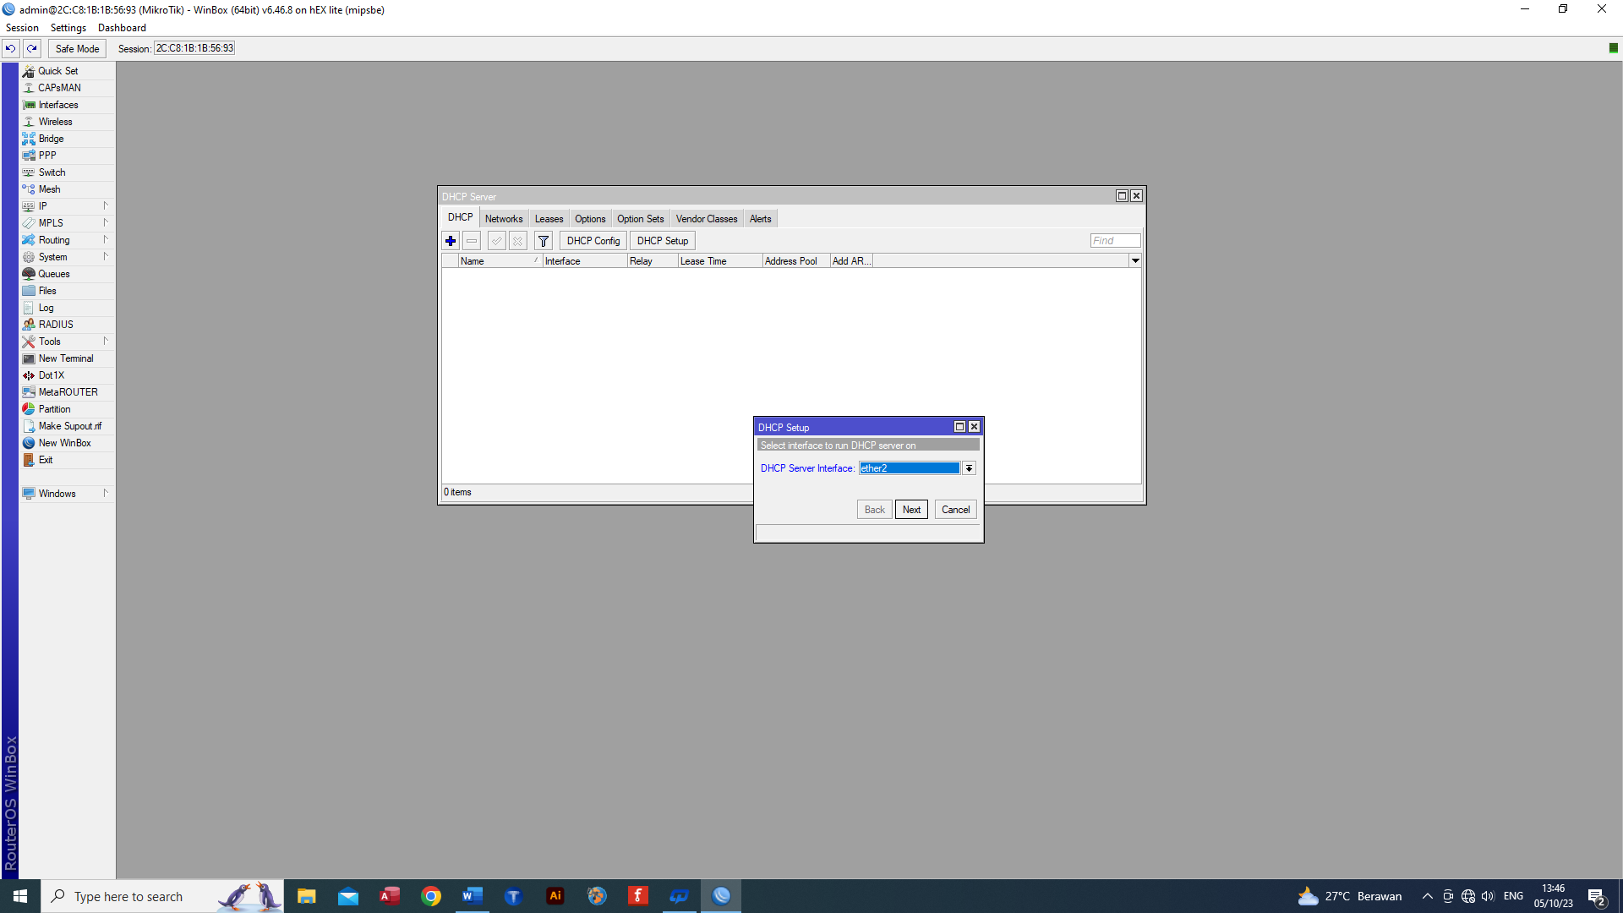

pilih server interface nya pilih ethr 2 kemudian next

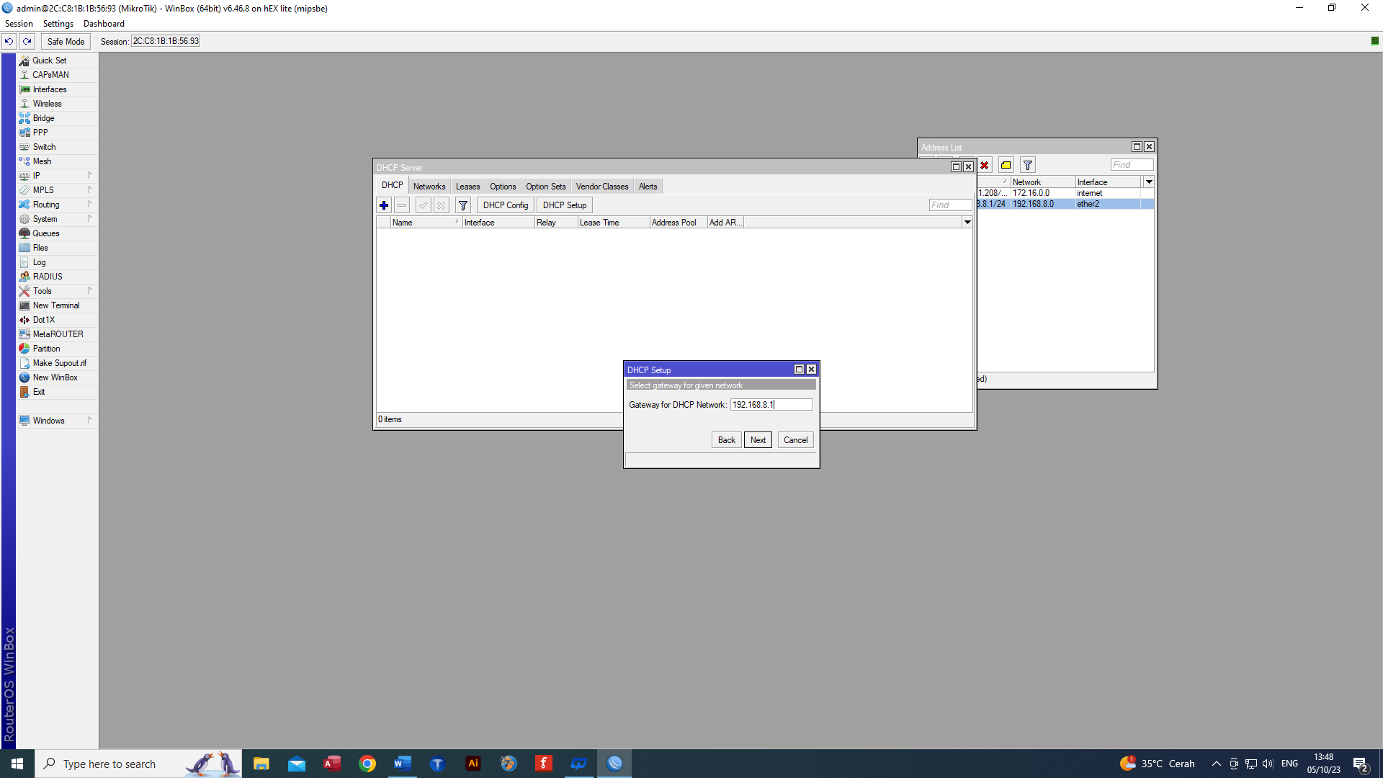

Masukan ip gateway lalu next

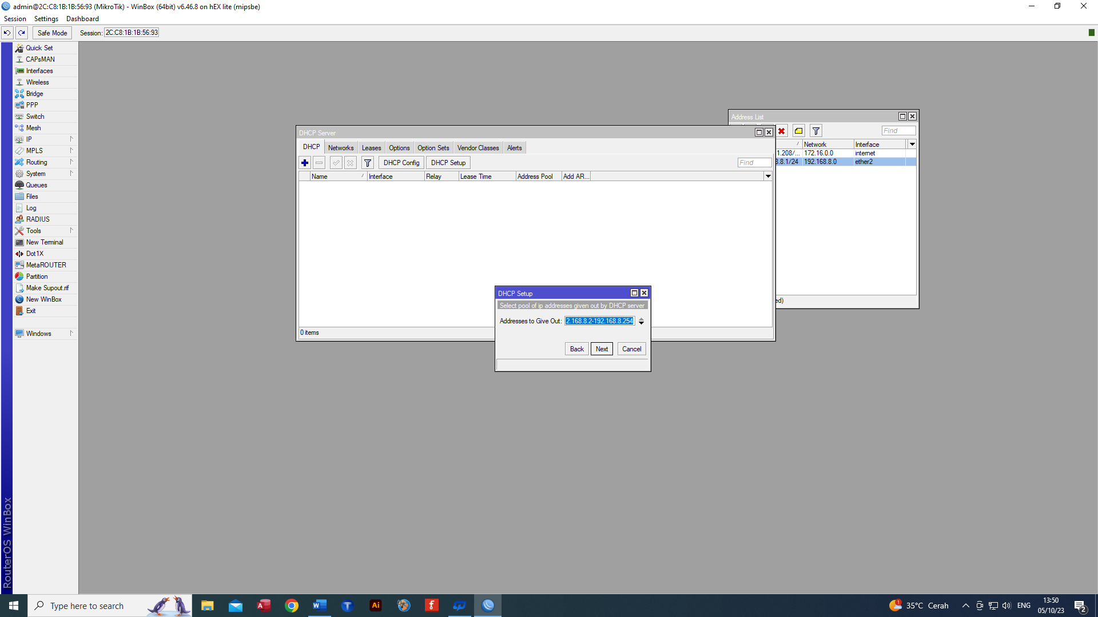

Address given out, seberapa banyak alamat yang mau dikasih, lalu next

Masukan dns server lalu next

Masukan lease time atau lalu next, sampai success

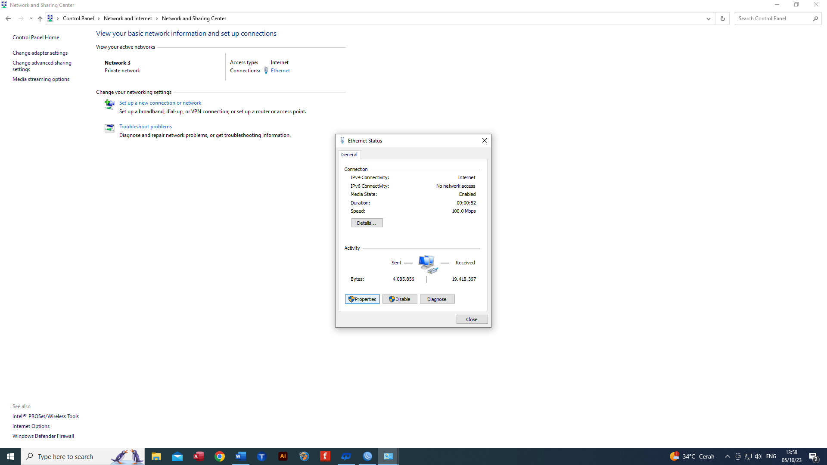

Di dalam control panel klik properties lalu klik 2 dalam ipv 4

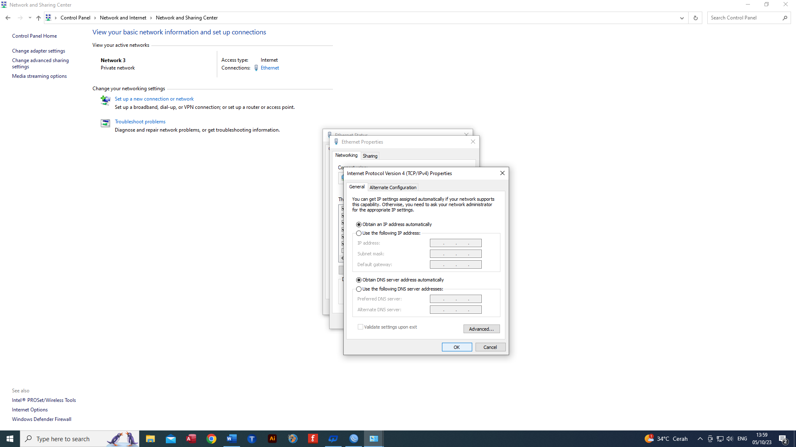

Ganti menjadi obtain an IP address

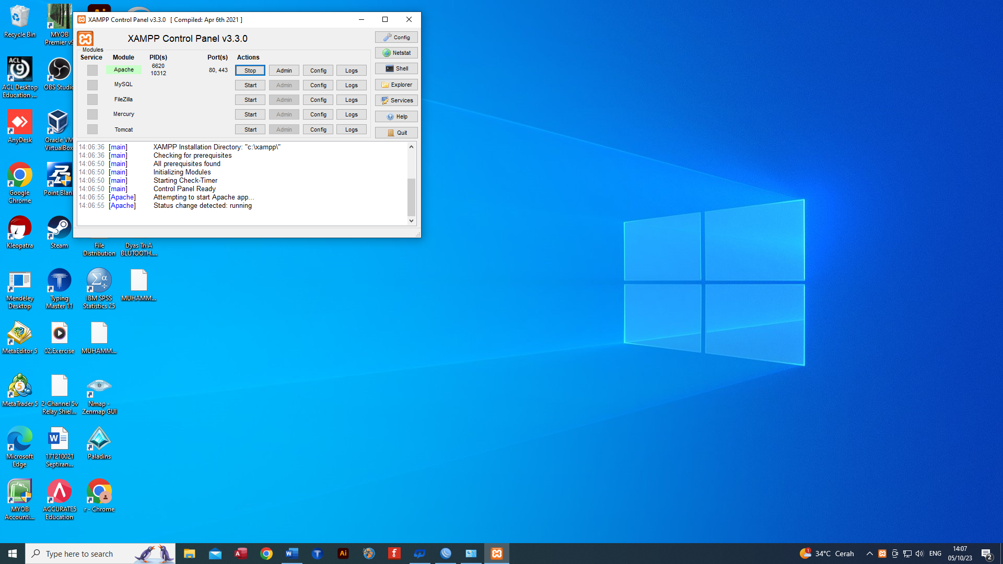

Nyalakan apache xampp lalu klik admin maka akan masuk ke localhost

Sublime, open folder lalu pilih local disk c, xampp, htdocs, buat folder baru

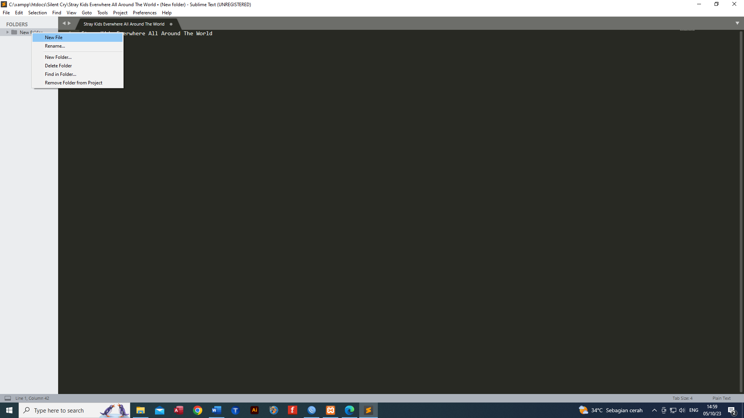

Pilih new file lalu ketikan isinya kemudian save (Ctrl S)

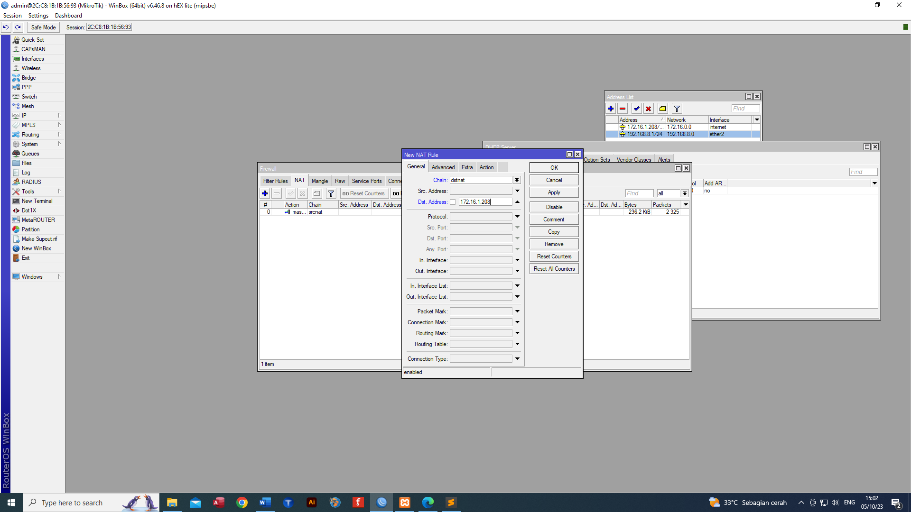

Untuk dst port jangan pakai 80

Mengetahui ip komputer

Apply

Masukan alamat ip dan port punya orang lain

Untuk memindahkan dns agar dns fix

Bagian action

Buat (+) yang sama seperti tadi tapi di ganti protocol pada general adalah udp

**Layer 7 protocol**

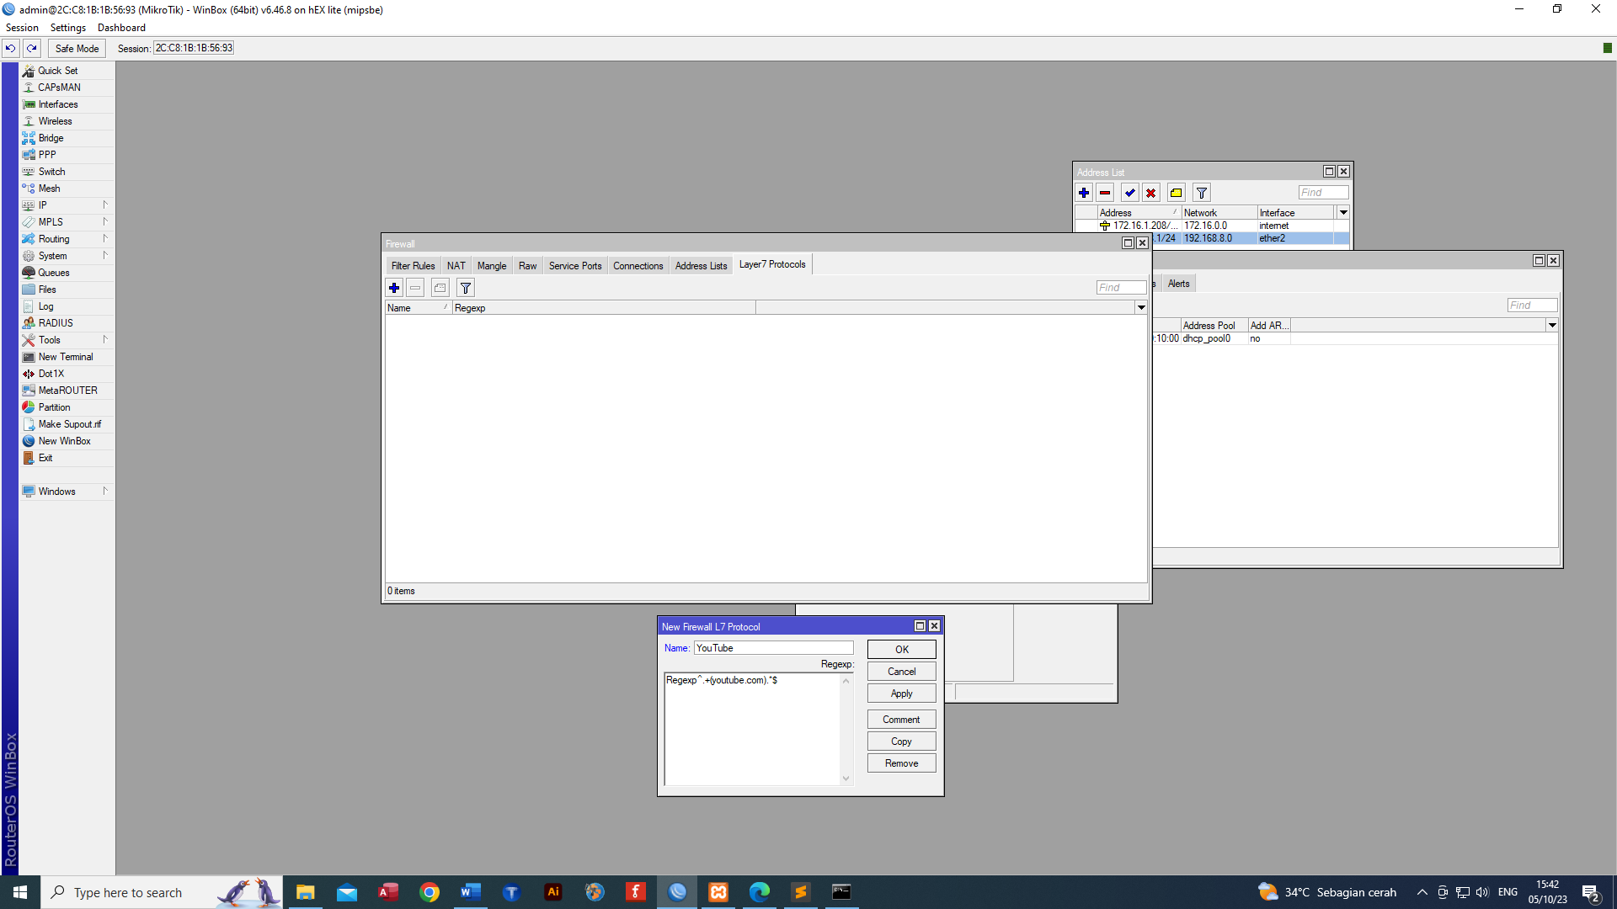

Masih di dalam firewall pilih layer 7 protocol lalu (+)

Jika masih bisa diakses maka hapus regexp

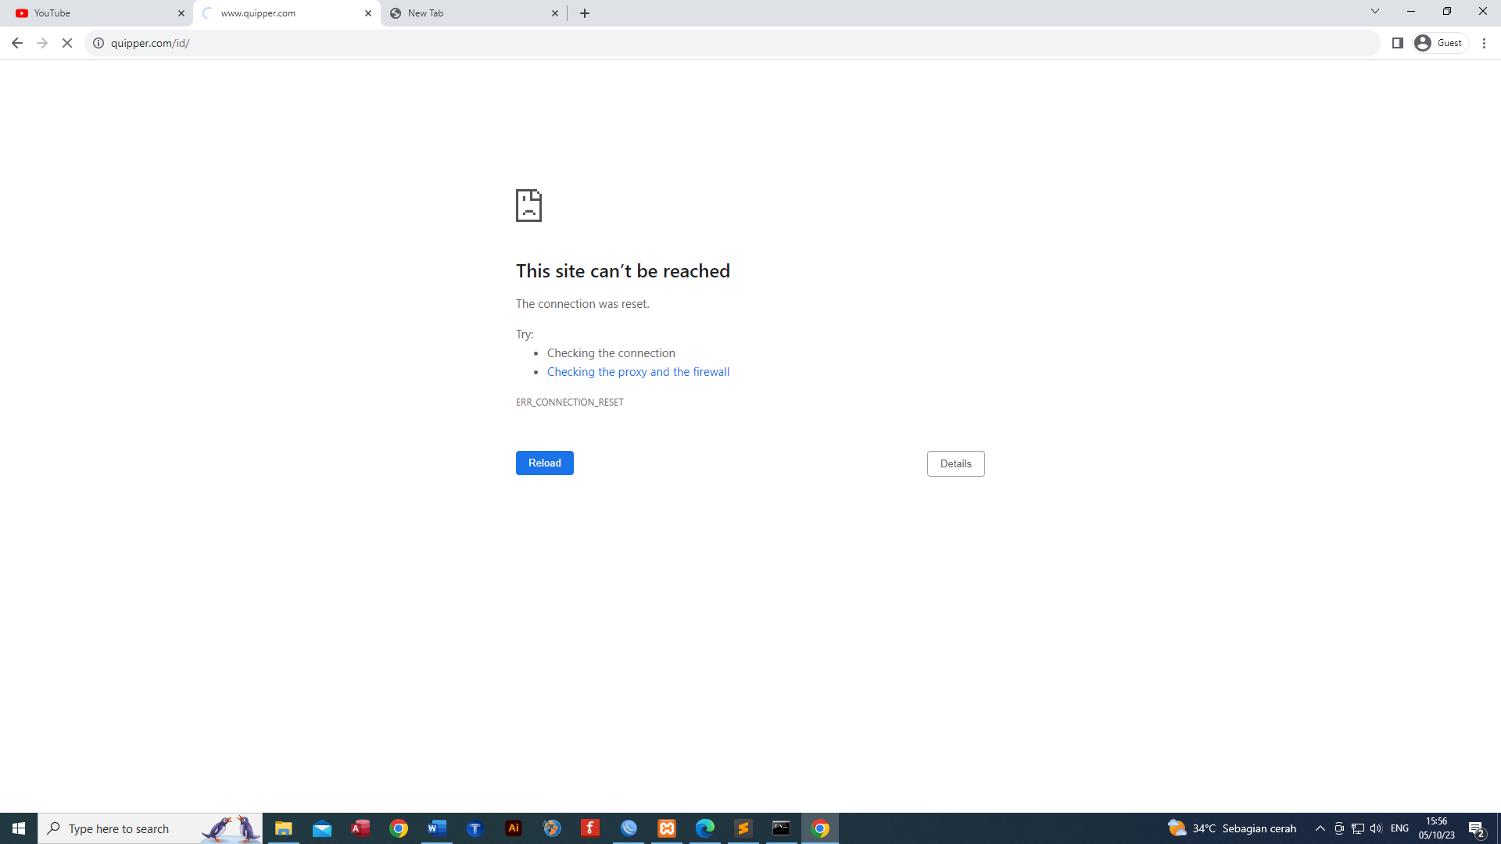

Situs pun tidak bisa diakses

Di dalam firewall address list

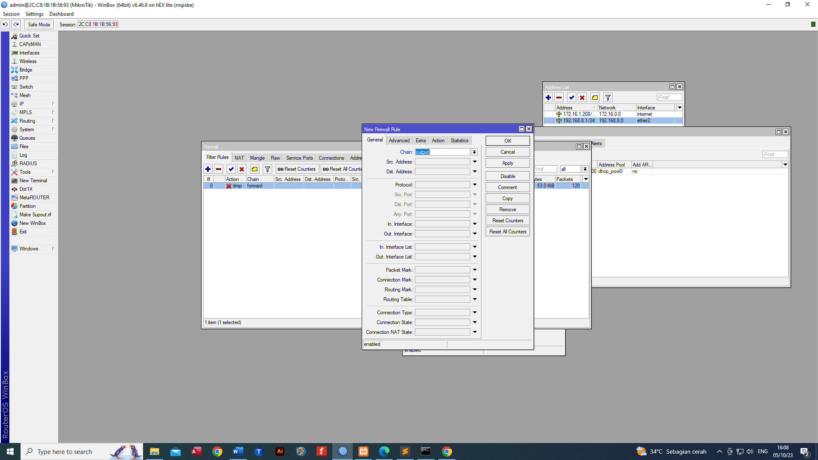

Maka